**R3 10m AIR RIFLE PRONE MIXED SH1 (WED 8 NOV 2017)**

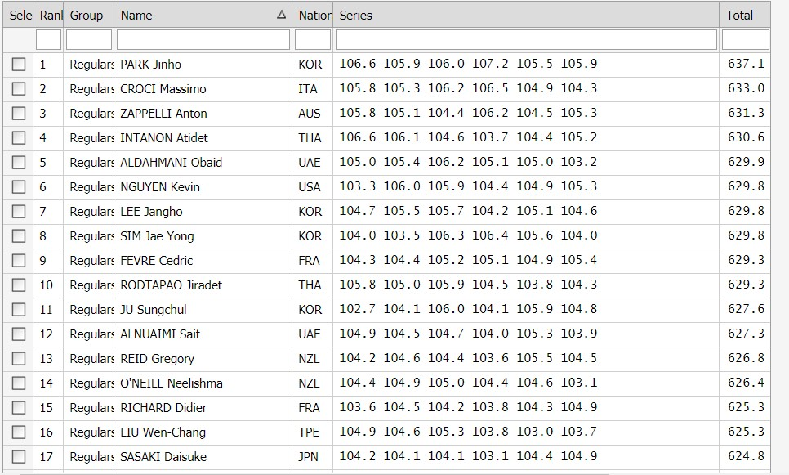

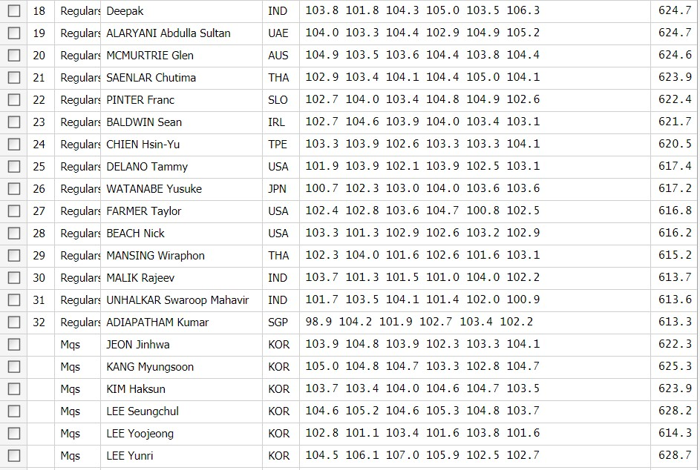

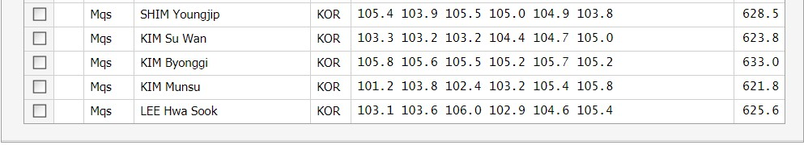

**Final**

